|  |  |  |
| --- | --- | --- |
| Checkpoint III | Checkpoint III: Visualization Sketch | |
| Group: | G16 |
| Date: | 2020/10/30 |
|  |  |

# Overview

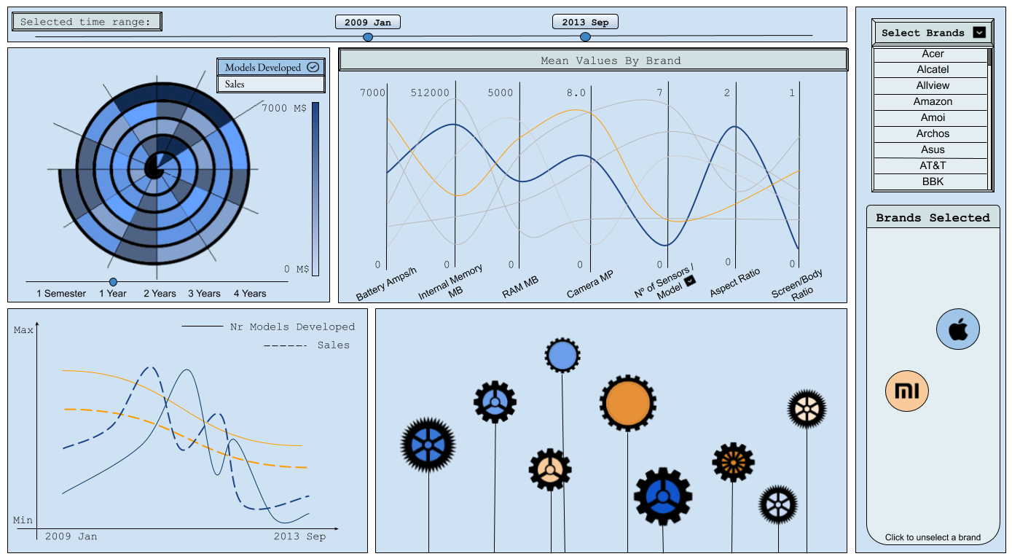

# Visual Encoding

First, when the user accesses our visualization, all brands are unselected but shown with a grey scale.

In our visualization, the user can select, at the top, the time range that they would like that the visualization showed. This time range will affect all the idioms in our visualization in an interactive way. They can also select new brands to be displayed by selecting them in the dropdown list on the top right.

Across all our idioms, the channel used to display which brand the information is associated with is the color hue.

There are **five different idioms**: spiral chart, parallel coordinates chart, line chart, small multiples of line chart, and glyph chart. All interconnected with each other.

In the **spiral chart** each interval represents, through the channel of color saturation, either the number of models developed or the sales (which of these is displayed can be selected on the top right side of the graph). Each of these colored areas refers to one time unit, depending on the selected unit on the slider below the chart, which represents what one whole loop corresponds to. The first date on the range is towards the center of the spiral, while the last one is on the edge of the spiral. Hovering over one area will show the exact number of models or sales in that time unit.

In the **parallel coordinates chart**, each axis represents the mean value of seven attributes for each brand on the selected time range (battery amps/h, internal memory MB, ram MB, camera MP, number of sensors per model, aspect ratio and screen body ratio). The order in which these attributes are displayed can be changed through interactivity. Each line on this chart is associated with a brand, colored lines are associated with selected brands (represented through the channel hue) and unselected brands are represented with grey. It is important to notice that the attribute *number of sensor per model* has a drop down list with each sensor that our dataset has and by choosing one of them instead of the number of sensors, the axis represents the percentage of models produced by that brand on the given time range with that specific sensor.

In the **line chart**, there are two axes. The x axis represents the time, while the y axis represents the sales (through the mark simple line) and the number of models developed by the brand (through the mark dashed line), in the selected time range. By clicking on an axis of the parallel coordinates chart, a phone attribute is selected and displayed on this line chart (through the mark dotted line). Each line is associated with a brand through the channel color hue.

In the **small multiples**

In the **glyph chart**, each glyph (with the mark being a smartphone) represents a model developed by one of the selected brands. There are several channels to take into consideration on the glyphs:

* *Height of the glyph* represent the attribute **time of model announcement**;
* *Size of the circle (on camera) on top/right of the glyph* represents the attribute **camera MP**;
* *Size of the screen* represents the attribute **screen/body ratio**;
* *Size of the glyph* represents the attribute **aspect ratio**;

# Answering the Questions

* *“What are the brands that manufacture models that prioritize battery life over other specs?”* - Looking at the parallel line chart attribute battery amps/h while having a few selected brands and seeing what brand corresponds to the highest curve on that axis.
* *“What cell phone brands had a peak in sales? When?”* - After selecting a few brands, looking at the line chart seeing if the dashed lines have a peak and when (by looking at where it was on the horizontal axis or by hovering over a specific point of the line.
* *“How many models did each brand develop in a given time period?”* - Hovering over the simple line when one brand is selected will show the total sales of the period represented by the graph.
* *“Is there a correlation between the number of models of a brand and that brand’s revenue?”* - Showed by looking at the line chart’s “number of models” and “sales” curves and seeing if when one changes, if the other also changes in the same manner.
* *“Is there a cyclic period of releases of phone models? Do the peaks occur every year? Every six months?”* - On the spiral chart, seeing if there is a higher amount of releases on the same side of the looping spiral, on different revolutions.
* *“When did a certain specification / hardware component start to be implemented on phones? What was its prevalence in phone models across the years?”* - When selecting one of the axes in the parallel coordinates chart, a line over time representing phone models implementing the component will be shown on the line chart. By looking when the line goes up from the bottom, it can be seen when it started being implemented.
* *“Is there a relationship between the sudden usage of a new component (like Bluetooth, DUAL SIM, etc. …) by a brand (Apple) and the change in revenue of that brand?”* - On the line chart, when there is a dotted line for a component, it can be compared with the simple line of sales. If the lines have similar shape, at the same points in time, it means sales and the usage of the component are likely correlated.

## Storyboards

Question *“Is there a relationship between the sudden usage of a new component (like Bluetooth, DUAL SIM, etc. …) by a brand (Apple) and the change in revenue of that brand?* “, in this case, we do it for the fingerprint sensor.